Pandas Tutorials

Pandas is an open-source software library designed for data manipulation and analysis. It provides data structures like series and DataFrames to easily clean, transform and analyze large datasets and integrates with other Python libraries, such as NumPy and Matplotlib.
It offers functions for data transformation, aggregation and visualization, which are important for analysis. Created by Wes McKinney in 2008, Pandas widely used by data scientists, analysts and researchers worldwide. Pandas revolves around two primary Data structures: Series (1D) for single columns and DataFrame (2D) for tabular data enabling efficient data manipulation.

Important Facts to Know :
- DataFrames: It is a two-dimensional data structure constructed with rows and columns, which is more similar to Excel spreadsheet.
- pandas: This name is derived for the term “panel data” which is econometrics terms of data sets.

What is Pandas Used for?
With pandas, you can perform a wide range of data operations, including
- Reading and writing data from various file formats like CSV, Excel and SQL databases.
- Cleaning and preparing data by handling missing values and filtering entries.
- Merging and joining multiple datasets seamlessly.
- Reshaping data through pivoting and stacking operations.
- Conducting statistical analysis and generating descriptive statistics.
- Visualizing data with integrated plotting capabilities.
Why Learn Pandas
Here’s why it’s worth learning:
- It offers a simple and intuitive way to work with structured data, especially using DataFrames.
- Makes data exploration easy, so you can quickly understand patterns or spot issues.
- Saves time by reducing the need for complex code.
- It’s widely used in industries like finance, healthcare, marketing and research.
- A must-have skill for data science, analytics and machine learning roles.

Pandas DataFrame
A DataFrame is a two-dimensional, size-mutable and potentially heterogeneous tabular data structure with labeled axes (rows and columns).
- Creating a DataFrame

Creating an Empty DataFrame
An empty DataFrame in pandas is a table with no data but can have defined column names and indexes. It is useful for setting up a structure before adding data dynamically. An empty DataFrame can be created just by calling a dataframe constructor.
import pandas as pd
df = pd.DataFrame()
print(df)

Creating a DataFrame from a List
A simple way to create a DataFrame is by using a single list. Pandas automatically assigns index values to the rows when you pass a list.
- Each item in the list becomes a row.
- The DataFrame consists of a single unnamed column.
import pandas as pd
lst = ['Geeks', 'For', 'Geeks', 'is',
'portal', 'for', 'Geeks']
df = pd.DataFrame(lst)
print(df)

Creating DataFrame from dict of Numpy Array
We can create a Pandas DataFrame using a dictionary of NumPy arrays. Each key in the dictionary represents a column name and the corresponding NumPy array provides the values for that column.
import numpy as np
import pandas as pd
data = np.array([[1, 2, 3], [4, 5, 6], [7, 8, 9]])
df = pd.DataFrame(data, columns=['A', 'B', 'C'])
print(df)

Creating a DataFrame from a List of Dictionaries
We can also create dataframe using List of Dictionaries. It represents data where each dictionary corresponds to a row. This method is useful for handling structured data from APIs or JSON files. It is commonly used in web scraping and API data processing since JSON responses often contain lists of dictionaries.
import pandas as pd
dict = {'name':["aparna", "pankaj", "sudhir", "Geeku"],
'degree': ["MBA", "BCA", "M.Tech", "MBA"],
'score':[90, 40, 80, 98]}
df = pd.DataFrame(dict)
print(df)
- Pandas Dataframe Index

Pandas Dataframe Index
Index in pandas dataframe act as reference for each row in dataset. It can be numeric or based on specific column values. The default index is usually a RangeIndex starting from 0, but you can customize it for better data understanding. You can easily access the current index of a dataframe using the index attribute. Let's us understand with the help of an example:
import pandas as pd
data = {'Name': ['John', 'Alice', 'Bob', 'Eve', 'Charlie'],
'Age': [25, 30, 22, 35, 28],
'Gender': ['Male', 'Female', 'Male', 'Female', 'Male'],
'Salary': [50000, 55000, 40000, 70000, 48000]}
df = pd.DataFrame(data)
print(df.index) # Accessing the index

2. Setting a Custom Index
To set a custom index, you can use the set_index() method, allowing you to set a custom index based on a column, such as Name or Age.
# Set 'Name' column as the index
df_with_index = df.set_index('Name')
print(df_with_index)
There are various operations you can perform with the DataFrame index, such as resetting it, changing it, or indexing with loc[]. Let's understand these as well:
3. Resetting the Index
If you need to reset the index back to default integer index, use reset_index() method. This will convert the current index into a regular column and create a new default index.
# Reset the index back to the default integer index
df_reset = df.reset_index()
print(df_reset)

4. Indexing with loc
The loc[] method in pandas allows to access rows and columns of a dataFrame using their labels, making it easy to retrieve specific data points.
row = df.loc['Alice']
print(row)

The df.loc[] function in Pandas is a very powerful method used for label-based indexing in DataFrames. It allows you to access a group of rows and columns by labels or a boolean array. The index or columns must be labels, not integer positions. It's one of the most commonly used functions for data selection and manipulation in Pandas.
Syntax:
python
CopyEdit
df.loc[row_label, column_label]
- row_label: This can be:
  - A single label (row index).
  - A list of labels (multiple row indices).
  - A slice of labels.
  - A boolean array (same length as the number of rows).
- column_label: This can be:
  - A single column label.
  - A list of column labels.
  - A slice of column labels.
  - A boolean array (same length as the number of columns).
Key Features:
- Label-based selection: Works with row and column labels (i.e., index names or column names).
- Includes the endpoint in slices: When using slices, df.loc[] includes the endpoint (contrary to df.iloc[]).
- Supports Boolean indexing: You can use conditions to filter rows or columns based on boolean values.
- Can modify the DataFrame: You can use df.loc[] to modify the data in a specific row/column.

Examples of df.loc[]:
1. Select a Single Row by Label:
python
CopyEdit
import pandas as pd

data = {'A': [1, 2, 3], 'B': [4, 5, 6]}
df = pd.DataFrame(data, index=['a', 'b', 'c'])

# Select row with label 'a'
print(df.loc['a'])
Output:
less
CopyEdit
A 1
B 4
Name: a, dtype: int64
2. Select a Single Element by Row and Column Label:
python
CopyEdit
# Select the element at row 'a' and column 'B'
print(df.loc['a', 'B'])
Output:
CopyEdit
4
3. Select Multiple Rows and Columns by Labels:
python
CopyEdit
# Select rows 'a' and 'c', and columns 'A' and 'B'
print(df.loc[['a', 'c'], ['A', 'B']])
Output:
css
CopyEdit
A B
a 1 4
c 3 6
4. Select a Range of Rows Using Label Slicing:
# Select rows from 'a' to 'b' (inclusive of 'b')
print(df.loc['a':'b'])
Output:
A B
a 1 4
b 2 5
5. Select All Rows for a Specific Column:
# Select all rows of column 'B'
print(df.loc[:, 'B'])
Output:
a 4
b 5
c 6
Name: B, dtype: int64
6. Select Rows Based on Conditions (Boolean Indexing):
# Select rows where column 'A' is greater than 1
print(df.loc[df['A'] > 1])
Output:
A B
b 2 5
c 3 6
7. Modify Values Using df.loc[]:
python
CopyEdit
# Change value of 'B' in row 'a' to 10
df.loc['a', 'B'] = 10
print(df)
Output:
A B
a 1 10
b 2 5
c 3 6
8. Select Multiple Rows and Columns Using Boolean Arrays:
# Select rows where column 'A' is greater than 1 and only 'A' column
print(df.loc[df['A'] > 1, 'A'])
Output:
b 2
c 3
Name: A, dtype: int64

Detailed Breakdown of Parameters:
- row_label:
  - Can be a single label or a list of labels (i.e., index values).
  - You can use a slice of labels, which will include the endpoint.
  - Boolean indexing is supported (you can filter rows based on a condition).
- column_label:
  - Can be a single column label or a list of column labels.
  - You can slice columns as well.
  - Boolean indexing is also possible for selecting specific columns based on conditions.
Key Points to Remember:
- Includes the endpoint when using slicing, unlike df.iloc[] which excludes the endpoint.
- Supports both row and column indexing simultaneously.
- Allows modification of DataFrame elements in place.
- Supports Boolean indexing for filtering data based on conditions.

df.iloc in Pandas
df.iloc[] is an indexer in Pandas used for integer-location based indexing. It allows you to select data from a DataFrame using row and column positions (integer indices), rather than the labels (which is done by df.loc[]). This makes df.iloc[] very useful when you want to work with the position of rows and columns directly.

🔹 Basic Syntax:
df.iloc[row_indexer, column_indexer]
- row_indexer: The index or range of indices to select the rows.
- column_indexer: The index or range of indices to select the columns.
Both row and column indexers are 0-based (i.e., the first row/column has index 0).

🔸 Parameters for df.iloc[]:
Parameter | Description
row_indexer | The row(s) to select. It can be a single integer, a list of integers, a slice, or a boolean array.
column_indexer | The column(s) to select. Similar to row_indexer, it can be a single integer, a list of integers, a slice, or a boolean array.
🔹 Examples:
1. Selecting a single row:
To select a specific row by its integer index:
import pandas as pd

data = {'A': [1, 2, 3], 'B': [4, 5, 6], 'C': [7, 8, 9]}
df = pd.DataFrame(data)

# Select the first row (index 0)
print(df.iloc[0])
Output:
A 1
B 4
C 7
Name: 0, dtype: int64
2. Selecting a specific element (row, column):
To select an element from a specific row and column using integer indices:
# Select the element at row 1 and column 2 (indexing starts from 0)
print(df.iloc[1, 2])
Output:
8
3. Selecting multiple rows:
You can select multiple rows by passing a list of indices:
# Select rows 0 and 2
print(df.iloc[[0, 2]])
Output:
A B C
0 1 4 7
2 3 6 9
4. Selecting rows with a range (slice):
You can use slices to select a range of rows:
# Select rows 1 to 2 (exclusive of index 3)
print(df.iloc[1:3])
Output:
css
CopyEdit
A B C
1 2 5 8
2 3 6 9
5. Selecting all rows but specific columns:
To select all rows for specific columns (e.g., the first two columns):
# Select all rows for the first two columns
print(df.iloc[:, :2])
Output:
css
CopyEdit
A B
0 1 4
1 2 5
2 3 6
6. Selecting specific rows and specific columns:
You can select a specific subset of rows and columns by combining row and column indexers:
# Select rows 0 and 2, and columns 0 and 1
print(df.iloc[[0, 2], [0, 1]])
Output:
A B
0 1 4
2 3 6
7. Using boolean arrays for selection:
You can use a boolean array for row selection. This is less common but can be useful in certain scenarios:
# Boolean array for selecting rows
print(df.iloc[[True, False, True], :])
Output:
A B C
0 1 4 7
2 3 6 9

🔹 Common Methods with df.iloc[]:
Although df.iloc[] is mainly for selecting rows and columns based on their integer position, you can combine it with other methods for filtering, manipulating, or analyzing data:
1. .values: Convert DataFrame to a NumPy array:
# Convert the values of the first two rows to a NumPy array
arr = df.iloc[:2].values
print(arr)
Output:
[[1 4 7]
[2 5 8]]
2. .shape: Get the shape of the selected rows and columns:
# Get the shape of the selection
print(df.iloc[:2, :2].shape)
Output:
(2, 2)
3. .head() and .tail(): Preview first or last few rows:
# Select the first 3 rows
print(df.iloc[:3].head())
4. .iloc for setting values:
You can also use iloc to modify values in your DataFrame:
# Change the value at row 0, column 1
df.iloc[0, 1] = 100
print(df)
Output:
A B C
0 1 100 7
1 2 5 8
2 3 6 9

🔹 Key Differences: df.loc[] vs df.iloc[]
- df.loc[]: Label-based indexing. It uses row and column labels (names).
- df.iloc[]: Integer-location based indexing. It uses the integer positions of rows and columns.
Example:
- df.loc[0, 'A']: Selects the value in row labeled 0 and column labeled 'A'.
- df.iloc[0, 0]: Selects the value in the first row and first column (index 0).

🧠 Summary:
- df.iloc[] is used for integer-based indexing, meaning you select rows and columns based on their integer positions (starting from 0).
- It supports various indexers, including integers, lists of integers, slices, and boolean arrays.
- It's especially useful for programmatically selecting or modifying parts of a DataFrame based on their location in the dataset.

5. Changing the Index
Change the index of dataFrame, with help of set_index() method; allows to set one or more columns as the new index.
# Set 'Age' as the new index
df_with_new_index = df.set_index('Age')
print(df_with_new_index)
Here are some Key Takeaways:
- Use .loc[] for label-based row selection and set_index() to set custom indices.
- Access the index with .index and reset_index() restores the default index, with an option to drop the old index.

- Pandas Access DataFrame

Accessing a dataframe in pandas involves retrieving, exploring, and manipulating data stored within this structure. The most basic form of accessing a DataFrame is simply referring to it by its variable name. This will display the entire DataFrame, which includes all rows and columns.

import pandas as pd
data = {'Name': ['John', 'Alice', 'Bob', 'Eve', 'Charlie'],
'Age': [25, 30, 22, 35, 28],
'Gender': ['Male', 'Female', 'Male', 'Female', 'Male'],
'Salary': [50000, 55000, 40000, 70000, 48000]}
df = pd.DataFrame(data)
# Display the entire DataFrame
print(df)
Output
Name Age Gender Salary
0 John 25 Male 50000
1 Alice 30 Female 55000
2 Bob 22 Male 40000
3 Eve 35 Female 70000
4 Charlie 28 Male 48000
In addition to accessing the entire DataFrame there are several other methods to effectively retrieve and manipulate data within a Pandas DataFrame. Let's have a look on that:
1. Accessing Columns From DataFrame
Columns in a DataFrame can be accessed individually using bracket notation Accessing a column retrieves that column as a Series, which can then be further manipulated.
# Access the 'Age' column
age_column = df['Age']
print(age_column)
Output
0 25
1 30
2 22
3 35
4 28
Name: Age, dtype: int64
2. Accessing Rows by Index
To access specific rows in a DataFrame, you can use iloc (for positional indexing) or loc (for label-based indexing). These methods allow you to retrieve rows based on their index positions or labels.
# Access the row at index 1 (second row)
second_row = df.iloc[1]
print(second_row)
Output
Name Alice
Age 30
Gender Female
Salary 55000
Name: 1, dtype: object
3. Accessing Multiple Rows or Columns
You can access multiple rows or columns at once by passing a list of column names or index positions. This is useful when you need to select several columns or rows for further analysis.
# Access the first three rows and the 'Name' and 'Age' columns
subset = df.loc[0:2, ['Name', 'Age']]
print(subset)
Output
Name Age
0 John 25
1 Alice 30
2 Bob 22
4. Accessing Rows Based on Conditions
Pandas allows you to filter rows based on conditions, which can be very powerful for exploring subsets of data that meet specific criteria.
# Access rows where 'Age' is greater than 25
filtered_data = df[df['Age'] > 25]
print(filtered_data)
Output
Name Age Gender Salary
1 Alice 30 Female 55000
3 Eve 35 Female 70000
4 Charlie 28 Male 48000
5. Accessing Specific Cells with at and iat
If you need to access a specific cell, you can use the .at[] method for label-based indexing and the .iat[] method for integer position-based indexing. These are optimized for fast access to single values.
# Access the 'Salary' of the row with label 2
salary_at_index_2 = df.at[2, 'Salary']
print(salary_at_index_2)
Output
40000
Here are some Key Takeaways:
- Access a DataFrame by its variable name to view all data, and use bracket notation for columns and loc/iloc for rows.
- Retrieve multiple rows or columns simultaneously by passing lists of names or indices.
- Filter rows based on conditions to explore specific subsets of data effectively.

- Indexing and Selecting Data with Pandas

Indexing in Pandas refers to selecting specific rows and columns from a DataFrame. It allows you to subset data in various ways, such as selecting all rows with specific columns, some rows with all columns, or a subset of both rows and columns. This technique is also known as Subset Selection.
Let’s learn how to use different techniques for indexing and selecting data with Pandas.
Indexing Data using the [] Operator
The most straightforward way to index data in Pandas is by using the [] operator. This method can be used to select individual columns or multiple columns.
Selecting a Single Column
To select a single column, you simply reference the column name inside square brackets:
import pandas as pd
# Load the data
data = pd.read_csv("nba.csv", index_col="Name")
print("Dataset")
display(data.head(5))
# Select a single column
first = data["Age"]
print("\nSingle Column selected from Dataset")
display(first.head(5))
Output:
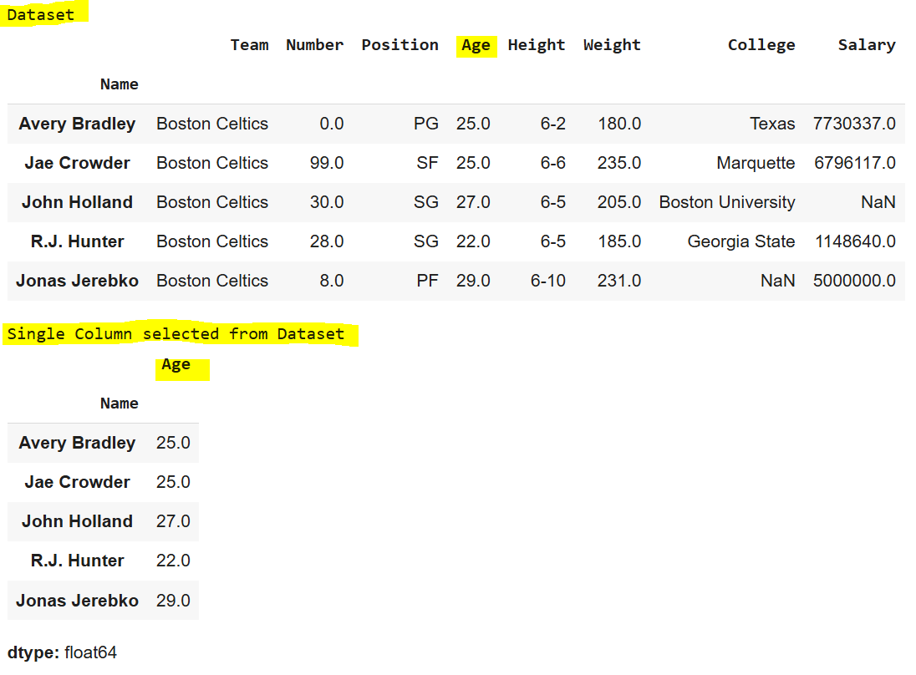
Selecting Multiple Columns
To select multiple columns, pass a list of column names:
first = data[["Age", "College", "Salary"]]
print("\nMultiple Columns selected from Dataset")
display(first.head(5))
Output:
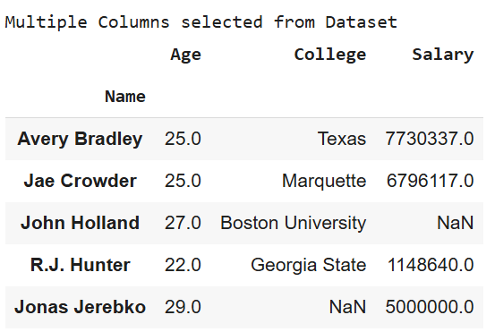
Pandas offers several indexing methods to efficiently extract elements, rows, and columns from a DataFrame. These methods, while similar, have distinct behaviors. The four main types of indexing in Pandas are:
- DataFrame[]: Known as the indexing operator, used for basic selection.
- DataFrame.loc[]: Label-based indexing for selecting data by row/column labels.
- DataFrame.iloc[]: Position-based indexing for selecting data by row/column integer positions.
Together, these indexing methods, also called “indexers,” are the most common ways to access data in a Pandas DataFrame.

Indexing a DataFrame using .loc[ ]
The .loc[] function in Pandas is used for selecting data by row and column labels. Unlike the indexing operator, .loc[] can select subsets of rows and columns simultaneously, offering flexibility in data retrieval.
Selecting a single row
To select a single row, provide the row label inside the .loc[] function:
# importing pandas package
import pandas as pd
# making data frame from csv file
data = pd.read_csv("nba.csv", index_col ="Name")
# retrieving row by loc method
first = data.loc["Avery Bradley"]
second = data.loc["R.J. Hunter"]
print(first, "\n\n\n", second)
Output:
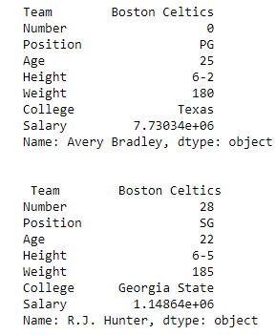
As shown in the output image, two series were returned since there was only one parameter both of the times.
Selecting multiple rows
For multiple rows, pass a list of row labels to .loc[]:
# Select multiple rows
first = data.loc[["Avery Bradley", "R.J. Hunter"]]
display(first)
Output:
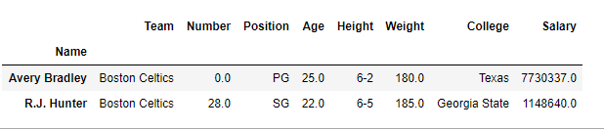
Selecting Specific Rows and Columns
To select specific rows and columns, provide both row labels and column names as lists:
Dataframe.loc[["row1", "row2"], ["column1", "column2", "column3"]]
# Select two rows and three columns
first = data.loc[["Avery Bradley", "R.J. Hunter"], ["Team", "Number", "Position"]]
print(first)
Output:
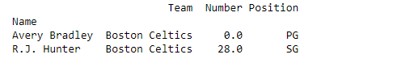
Selecting all of the rows and some columns
To select all rows and specific columns, use a colon [:] to indicate all rows, followed by the list of column names:
Dataframe.loc[:, ["column1", "column2", "column3"]]
# Select all rows and specific columns
first = data.loc[:, ["Team", "Number", "Position"]]
print(first)
Output:
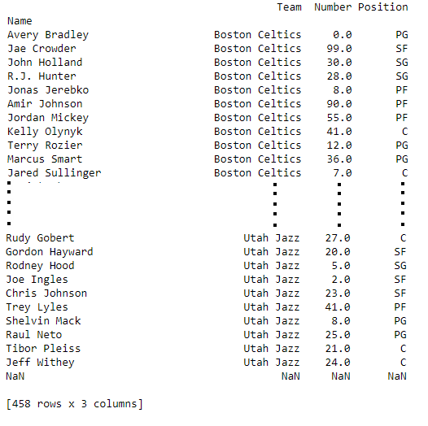
The .loc[] method in Pandas offers a powerful way to index and filter data using labels, making it a core tool for data selection.

Indexing a DataFrame using .iloc[ ]
The .iloc[] function in Pandas allows data selection based on integer positions (rather than labels). It is similar to .loc[], but only accepts integer-based indices to specify rows and columns.
Selecting a Single Row
To select a single row using .iloc[], provide the integer position of the row:
import pandas as pd
data = pd.read_csv("nba.csv", index_col="Name")
# Select a single row by position
row2 = data.iloc[3]
print(row2)
Output:
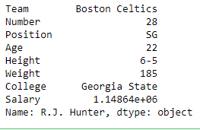
Selecting Multiple Rows
To select multiple rows, pass a list of integer positions:
# Select multiple rows by position
row2 = data.iloc[[3, 5, 7]]
display(row2)
Output:
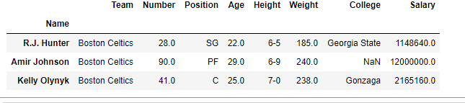
Selecting Specific Rows and Columns
To select specific rows and columns, provide integer positions for both rows and columns:
# Select two rows and two columns by position
row2 = data.iloc[[3, 4], [1, 2]]
print(row2)
Output:
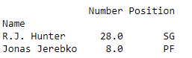
Selecting All Rows and Some Columns
To select all rows and specific columns, use a colon [:] for all rows and a list of column positions:
# Select all rows and specific columns
row2 = data.iloc[:, [1, 2]]
print(row2)
Output:
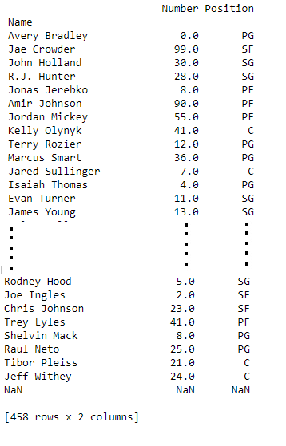
The .iloc[] method is a powerful way to select data by position, offering flexibility in accessing subsets of a DataFrame based on integer indexing.
Other methods for indexing in a Pandas DataFrame include:
deprecated ones:
Function | Description
DataFrame.head() | Return top n rows of a DataFrame.
DataFrame.tail() | Return bottom n rows of a DataFrame.
DataFrame.at[] | Access a single value for a row/column label pair.
DataFrame.iat[] | Access a single value for a row/column pair by integer position.
DataFrame.lookup() | Label-based “fancy indexing” function for DataFrame.
DataFrame.pop() | Return item and drop from DataFrame.
DataFrame.xs() | Return a cross-section (row(s) or column(s)) from the DataFrame.
DataFrame.get() | Get item from object for given key (e.g., DataFrame column).
DataFrame.isin() | Return a boolean DataFrame showing whether each element is contained in values.
DataFrame.where() | Return an object of the same shape with entries from self where cond is True, otherwise from other.
DataFrame.mask() | Return an object of the same shape with entries from self where cond is False, otherwise from other.
DataFrame.query() | Query the columns of a DataFrame with a boolean expression.
DataFrame.insert() | Insert a column into DataFrame at a specified location.
This table contains only active, non-deprecated methods for DataFrame indexing in Pandas. Let me know if you need more details!

- Slicing Pandas Dataframe

Slicing Pandas Dataframe
Slicing a Pandas DataFrame is a important skill for extracting specific data subsets. Whether you want to select rows, columns or individual cells, Pandas provides efficient methods like iloc[] and loc[]. In this guide we’ll explore how to use integer-based and label-based indexing to slice DataFrames effectively.
Create a Custom Dataframe
Let’s import pandas library and create pandas dataframe from custom nested list.
import pandas as pd

player_list = [['M.S.Dhoni', 36, 75, 5428000],
['A.B.D Villers', 38, 74, 3428000],
['V.Kohli', 31, 70, 8428000],
['S.Smith', 34, 80, 4428000],
['C.Gayle', 40, 100, 4528000],
['J.Root', 33, 72, 7028000],
['K.Peterson', 42, 85, 2528000]]

df = pd.DataFrame(player_list, columns=['Name', 'Age', 'Weight', 'Salary'])
print(df)
Output:
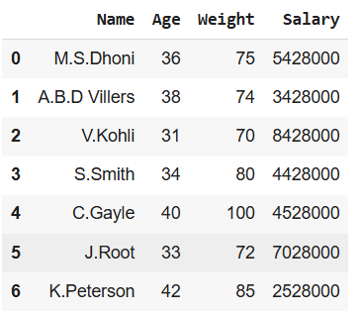
Slicing Using iloc[] (Integer-Based Indexing)
The iloc[] method in Pandas allows us to extract specific rows and columns based on their integer positions starting from 0. Each number represents a position in the DataFrame not the actual label of the row or column.
Slicing Rows in dataframe
Row slicing means selecting a specific set of rows from the DataFrame while keeping all columns.
df1 = df.iloc[0:4]
print(df1)
Output:
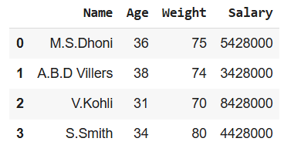
Slicing Columns in dataframe
Column slicing means selecting a specific set of columns from the DataFrame while keeping all rows.
df1 = df.iloc[:, 0:2]

print(df1)
Output:
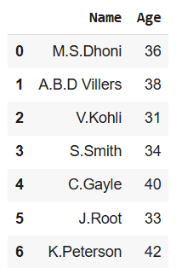
Selecting a Specific Cell in a Pandas DataFrame
If you need a single value from a DataFrame you can specify the exact row and column position
value = df.iloc[2, 3]
print("Specific Cell Value:", value)
Output:
Specific Cell Value: 8428000
Using Boolean Conditions in a Pandas DataFrame
Instead of selecting rows by index we can use Boolean conditions (e.g., Age > 35) to filter rows dynamically.
data = df[df['Age'] > 35].iloc[:, :]
print("\nFiltered Data based on Age > 35:\n", data)
Output:
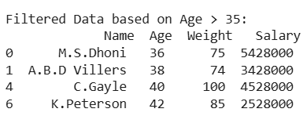
Slicing Using loc[]
We can also implement slicing using the loc function in Pandas but there are some limitations to be aware of. The loc function relies on labels meaning that if your DataFrame has custom labels instead of default integer indices you need to be careful with how you specify them.
Slicing Rows in Dataframe
With loc[] we can extract a range of rows by their labels instead of integer positions.
df.set_index('Name', inplace=True)
custom = df.loc['A.B.D Villers':'S.Smith']
print(custom)
Output:
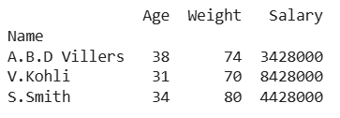
Selecting Specified cell in Dataframe
loc[] allows us to fetch a specific value based on row and column labels

value = df.loc['V.Kohli', 'Salary']
print("\nValue of the Specific Cell (V.Kohli, Salary):", value)
Output:
Value of the Specific Cell (V.Kohli, Salary): 8428000

- Filter Pandas Dataframe with multiple conditions

Filter Pandas Dataframe with multiple conditions
The reason is dataframe may be having multiple columns and multiple rows. Selective display of columns with limited rows is always the expected view of users. To fulfill the user's expectations and also help in machine deep learning scenarios, filtering of Pandas dataframe with multiple conditions is much necessary.
Let us see the different ways to do the same.
Creating a sample dataframe to proceed further
# import module
import pandas as pd

# assign data
dataFrame = pd.DataFrame({'Name': [' RACHEL ', ' MONICA ', ' PHOEBE ',
' ROSS ', 'CHANDLER', ' JOEY '],

'Age': [30, 35, 37, 33, 34, 30],

'Salary': [100000, 93000, 88000, 120000, 94000, 95000],

'JOB': ['DESIGNER', 'CHEF', 'MASUS', 'PALENTOLOGY',
'IT', 'ARTIST']})

# display dataframe
display(dataFrame)
Output:
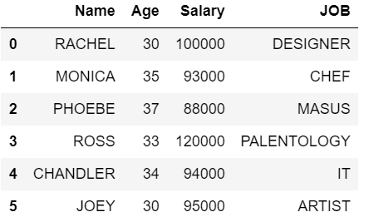
Filter Pandas Dataframe with multiple conditions Using loc
Here we will get all rows having Salary greater or equal to 100000 and Age < 40 and their JOB starts with ‘D’ from the dataframe. Print the details with Name and their JOB. For the above requirement, we can achieve this by using loc. It is used to access single or more rows and columns by label(s) or by a boolean array. loc works with column labels and indexes.
# import module
import pandas as pd

# assign data
dataFrame = pd.DataFrame({'Name': [' RACHEL ', ' MONICA ', ' PHOEBE ',
' ROSS ', 'CHANDLER', ' JOEY '],

'Age': [30, 35, 37, 33, 34, 30],

'Salary': [100000, 93000, 88000, 120000, 94000, 95000],

'JOB': ['DESIGNER', 'CHEF', 'MASUS', 'PALENTOLOGY',
'IT', 'ARTIST']})
# filter dataframe
display(dataFrame.loc[(dataFrame['Salary']>=100000) & (dataFrame['Age']< 40) & (dataFrame['JOB'].str.startswith('D')),
['Name','JOB']])
Output:
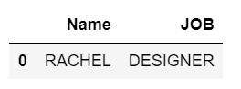
Output resolves for the given conditions and finally, we are going to show only 2 columns namely Name and JOB.

Filter Pandas Dataframe Using NumPy
Here will get all rows having Salary greater or equal to 100000 and Age < 40 and their JOB starts with ‘D’ from the data frame. We need to use NumPy.
# import module
import pandas as pd
import numpy as np

# assign data
dataFrame = pd.DataFrame({'Name': [' RACHEL', ' MONICA', ' PHOEBE', 'ROSS', 'CHANDLER', ' JOEY'],
'Age': [30, 35, 37, 33, 34, 30],
'Salary': [100000, 93000, 88000, 120000, 94000, 95000],
'JOB': ['DESIGNER', 'CHEF', 'MASUS', 'PALENTOLOGY', 'IT', 'ARTIST']})

# filter dataframe
filtered_values = np.where((dataFrame['Salary']>=100000) & (dataFrame['Age']< 40) & (dataFrame['JOB'].str.startswith('D')))
print(filtered_values)
display(dataFrame.loc[filtered_values])
Output:
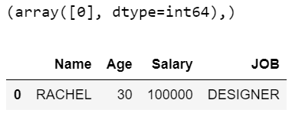
In the above example, print(filtered_values) will give the output as (array([0], dtype=int64),) which indicates the first row with index value 0 will be the output. After that output will have 1 row with all the columns and it is retrieved as per the given conditions.

Filter Pandas Dataframe Using Query (eval and query works only with columns)
In this approach, we get all rows having Salary lesser or equal to 100000 and Age < 40, and their JOB starts with ‘C’ from the dataframe. Its just query the columns of a DataFrame with a single or more Boolean expressions and if multiple, it is having & condition in the middle.
# import module
import pandas as pd

# assign data
dataFrame = pd.DataFrame({'Name': [' RACHEL ', ' MONICA ', ' PHOEBE ',
' ROSS ', 'CHANDLER', ' JOEY '],

'Age': [30, 35, 37, 33, 34, 30],

'Salary': [100000, 93000, 88000, 120000, 94000, 95000],

'JOB': ['DESIGNER', 'CHEF', 'MASUS', 'PALENTOLOGY',
'IT', 'ARTIST']})

# filter dataframe
display(dataFrame.query('Salary <= 100000 & Age < 40 & JOB.str.startswith("C").values'))
Output:
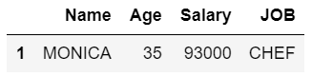
Pandas Boolean indexing multiple conditions standard way ("Boolean indexing" works with values in a column only)
In this approach, we get all rows having Salary lesser or equal to 100000 and Age < 40 and their JOB starts with ‘P’ from the dataframe. In order to select the subset of data using the values in the dataframe and applying Boolean conditions, we need to follow these ways
# import module
import pandas as pd

# assign data
dataFrame = pd.DataFrame({'Name': [' RACHEL ', ' MONICA ', ' PHOEBE ',
' ROSS ', 'CHANDLER', ' JOEY '],

'Age': [30, 35, 37, 33, 34, 30],

'Salary': [100000, 93000, 88000, 120000, 94000, 95000],

'JOB': ['DESIGNER', 'CHEF', 'MASUS', 'PALENTOLOGY',
'IT', 'ARTIST']})

# filter dataframe
display(dataFrame[(dataFrame['Salary']>=100000) & (dataFrame['Age']<40) & dataFrame['JOB'].str.startswith('P')][['Name','Age','Salary']])
Output:
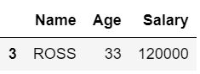
We are mentioning a list of columns that need to be retrieved along with the Boolean conditions and since many conditions, it is having '&'.
Eval multiple conditions ("eval" and "query" works only with columns )
Here, we get all rows having Salary lesser or equal to 100000 and Age < 40 and their JOB starts with ‘A’ from the dataframe.
# import module
import pandas as pd

# assign data
dataFrame = pd.DataFrame({'Name': [' RACHEL ', ' MONICA ', ' PHOEBE ',
' ROSS ', 'CHANDLER', ' JOEY '],

'Age': [30, 35, 37, 33, 34, 30],

'Salary': [100000, 93000, 88000, 120000, 94000, 95000],

'JOB': ['DESIGNER', 'CHEF', 'MASUS', 'PALENTOLOGY',
'IT', 'ARTIST']})

# filter dataframe
display(dataFrame[dataFrame.eval("Salary <=100000 & (Age <40) & JOB.str.startswith('A').values")])
Output:

Dataframes are a very essential concept in Python and filtration of data is required can be performed based on various conditions. They can be achieved in any one of the above ways. Points to be noted:
- loc works with column labels and indexes.
- eval and query works only with columns.
- Boolean indexing works with values in a column only

- Merging, Joining and Concatenating Dataframes

Pandas DataFrame is a two-dimensional size-mutable, potentially heterogeneous tabular data structure with labelled axes (rows and columns). A Data frame is a two-dimensional data structure, i.e., data is aligned in a tabular fashion in rows and columns. We can join, merge, and concat dataframe using different methods.
In Dataframe df.merge(),df.join(), and df.concat() methods help in joining, merging and concating different dataframe.

Concatenating DataFrame
In order to concat dataframe, we use concat() function which helps in concatenating a dataframe. We can concat a dataframe in many different ways, they are:
- Concatenating DataFrame using .concat()
- Concatenating DataFrame by setting logic on axes
- Concatenating DataFrame using .append()
- Concatenating DataFrame by ignoring indexes
- Concatenating DataFrame with group keys
- Concatenating with mixed ndims
Concatenating DataFrame using .concat() :
In order to concat a dataframe, we use .concat() function this function concat a dataframe and returns a new dataframe.
# importing pandas module
import pandas as pd
# Define a dictionary containing employee data
data1 = {'Name': ['Jai', 'Princi', 'Gaurav', 'Anuj'],
'Age': [27, 24, 22, 32],
'Address': ['Nagpur', 'Kanpur', 'Allahabad', 'Kannuaj'],
'Qualification': ['Msc', 'MA', 'MCA', 'Phd']}

# Define a dictionary containing employee data
data2 = {'Name': ['Abhi', 'Ayushi', 'Dhiraj', 'Hitesh'],
'Age': [17, 14, 12, 52],
'Address': ['Nagpur', 'Kanpur', 'Allahabad', 'Kannuaj'],
'Qualification': ['Btech', 'B.A', 'Bcom', 'B.hons']}
​
# Convert the dictionary into DataFrame
df = pd.DataFrame(data1, index=[0, 1, 2, 3])
# Convert the dictionary into DataFrame
df1 = pd.DataFrame(data2, index=[4, 5, 6, 7])
print(df, "\n\n", df1)
Now we apply .concat function in order to concat two dataframe.
# using a .concat() method
frames = [df, df1]
res1 = pd.concat(frames)
res1
Output :
As shown in the output image, we have created two dataframe after concatenating we get one dataframe.

Concatenating DataFrame by setting logic on axes :
In order to concat dataframe, we have to set different logic on axes. We can set axes in the following three ways:
- Taking the union of them all, join='outer'. This is the default option as it results in zero information loss.
- Taking the intersection, join='inner'.
- Use a specific index, as passed to the join_axes argument.
# importing pandas module
import pandas as pd
# Define a dictionary containing employee data
data1 = {'Name': ['Jai', 'Princi', 'Gaurav', 'Anuj'],
'Age': [27, 24, 22, 32],
'Address': ['Nagpur', 'Kanpur', 'Allahabad', 'Kannuaj'],
'Qualification': ['Msc', 'MA', 'MCA', 'Phd'],
'Mobile No': [97, 91, 58, 76]}
# Define a dictionary containing employee data
data2 = {'Name': ['Gaurav', 'Anuj', 'Dhiraj', 'Hitesh'],
'Age': [22, 32, 12, 52],
'Address': ['Allahabad', 'Kannuaj', 'Allahabad', 'Kannuaj'],
'Qualification': ['MCA', 'Phd', 'Bcom', 'B.hons'],
'Salary': [1000, 2000, 3000, 4000]}
# Convert the dictionary into DataFrame
df = pd.DataFrame(data1, index=[0, 1, 2, 3])
# Convert the dictionary into DataFrame
df1 = pd.DataFrame(data2, index=[2, 3, 6, 7])
print(df, "\n\n", df1)
Now we set axes join = inner for intersection of dataframe.
# applying concat with axes
# join = 'inner'
res2 = pd.concat([df, df1], axis=1, join='inner')
res2
Output :
As shown in the output image, we get the intersection of dataframe.

Now we set axes join = outer for union of dataframe.
# using a .concat for
# union of dataframe
res2 = pd.concat([df, df1], axis=1, sort=False)
res2
Output :
As shown in the output image, we get the union of dataframe
Now we used a specific index, as passed to the join_axes argument
# using join_axes
res3 = pd.concat([df, df1], axis=1, join_axes=[df.index])
res3
Output :

Concatenating DataFrame with group keys :
In order to concat dataframe with group keys, we override the column names with the use of the keys argument. Keys argument is to override the column names when creating a new DataFrame based on existing Series.
# importing pandas module
import pandas as pd
# Define a dictionary containing employee data
data1 = {'Name':['Jai', 'Princi', 'Gaurav', 'Anuj'],
'Age':[27, 24, 22, 32],
'Address':['Nagpur', 'Kanpur', 'Allahabad', 'Kannuaj'],
'Qualification':['Msc', 'MA', 'MCA', 'Phd']}
# Define a dictionary containing employee data
data2 = {'Name':['Abhi', 'Ayushi', 'Dhiraj', 'Hitesh'],
'Age':[17, 14, 12, 52],
'Address':['Nagpur', 'Kanpur', 'Allahabad', 'Kannuaj'],
'Qualification':['Btech', 'B.A', 'Bcom', 'B.hons']}
# Convert the dictionary into DataFrame
df = pd.DataFrame(data1,index=[0, 1, 2, 3])
# Convert the dictionary into DataFrame
df1 = pd.DataFrame(data2, index=[4, 5, 6, 7])
print(df, "\n\n", df1)
Now we use keys as an argument.
# using keys
frames = [df, df1 ]
res = pd.concat(frames, keys=['x', 'y'])
res
Output :

Concatenating with mixed ndims :
User can concatenate a mix of Series and DataFrame. The Series will be transformed to DataFrame with the column name as the name of the Series.
# importing pandas module
import pandas as pd
# Define a dictionary containing employee data
5
data1 = {'Name':['Jai', 'Princi', 'Gaurav', 'Anuj'],
6
'Age':[27, 24, 22, 32],
7
'Address':['Nagpur', 'Kanpur', 'Allahabad', 'Kannuaj'],
8
'Qualification':['Msc', 'MA', 'MCA', 'Phd']}
9

10
# Convert the dictionary into DataFrame
11
df = pd.DataFrame(data1,index=[0, 1, 2, 3])
12

13
# creating a series
14
s1 = pd.Series([1000, 2000, 3000, 4000], name='Salary')
15

16
print(df, "\n\n", s1)
Now we are going to mix Series and dataframe together.
1
# combining series and dataframe
2
res = pd.concat([df, s1], axis=1)
3

4
res
Output :
Merging DataFrame
Pandas have options for high-performance in-memory merging and joining. When we need to combine very large DataFrames, joins serve as a powerful way to perform these operations swiftly. Joins can only be done on two DataFrames at a time, denoted as left and right tables. The key is the common column that the two DataFrames will be joined on. It’s a good practice to use keys which have unique values throughout the column to avoid unintended duplication of row values. Pandas provide a single function, merge(), as the entry point for all standard database join operations between DataFrame objects.
There are four basic ways to handle the join (inner, left, right, and outer), depending on which rows must retain their data.
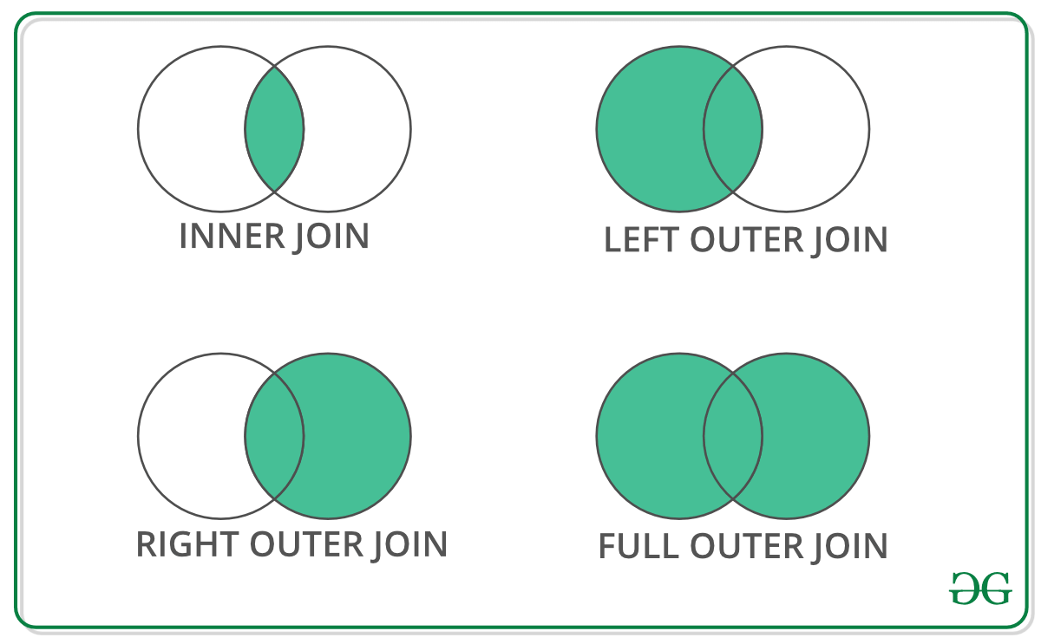Code #1 : Merging a dataframe with one unique key combination
# importing pandas module
import pandas as pd
# Define a dictionary containing employee data
data1 = {'key': ['K0', 'K1', 'K2', 'K3'],
'Name':['Jai', 'Princi', 'Gaurav', 'Anuj'],
'Age':[27, 24, 22, 32],}
# Define a dictionary containing employee data
data2 = {'key': ['K0', 'K1', 'K2', 'K3'],
'Address':['Nagpur', 'Kanpur', 'Allahabad', 'Kannuaj'],
'Qualification':['Btech', 'B.A', 'Bcom', 'B.hons']}
# Convert the dictionary into DataFrame
df = pd.DataFrame(data1)
# Convert the dictionary into DataFrame
df1 = pd.DataFrame(data2)
print(df, "\n\n", df1)
Now we are using .merge() with one unique key combination.
# using .merge() function
res = pd.merge(df, df1, on='key')
res
Output :
Code #2: Merging dataframe using multiple join keys.
# importing pandas module
import pandas as pd
# Define a dictionary containing employee data
data1 = {'key': ['K0', 'K1', 'K2', 'K3'],
'key1': ['K0', 'K1', 'K0', 'K1'],
'Name':['Jai', 'Princi', 'Gaurav', 'Anuj'],
'Age':[27, 24, 22, 32],}
# Define a dictionary containing employee data
data2 = {'key': ['K0', 'K1', 'K2', 'K3'],
'key1': ['K0', 'K0', 'K0', 'K0'],
'Address':['Nagpur', 'Kanpur', 'Allahabad', 'Kannuaj'],
'Qualification':['Btech', 'B.A', 'Bcom', 'B.hons']}
# Convert the dictionary into DataFrame
df = pd.DataFrame(data1)
# Convert the dictionary into DataFrame
df1 = pd.DataFrame(data2)
print(df, "\n\n", df1)
Now we merge dataframe using multiple keys.
# merging dataframe using multiple keys
res1 = pd.merge(df, df1, on=['key', 'key1'])
res1
Output :
Merging dataframe using how in an argument:
We use how argument to merge specifies how to determine which keys are to be included in the resulting table. If a key combination does not appear in either the left or right tables, the values in the joined table will be NA. Here is a summary of the how options and their SQL equivalent names:
MERGE METHOD | JOIN NAME | DESCRIPTION
left | LEFT OUTER JOIN | Use keys from left frame only
right | RIGHT OUTER JOIN | Use keys from right frame only
outer | FULL OUTER JOIN | Use union of keys from both frames
inner | INNER JOIN | Use intersection of keys from both frames
# importing pandas module
import pandas as pd
# Define a dictionary containing employee data
data1 = {'key': ['K0', 'K1', 'K2', 'K3'],
'key1': ['K0', 'K1', 'K0', 'K1'],
'Name':['Jai', 'Princi', 'Gaurav', 'Anuj'],
'Age':[27, 24, 22, 32],}
# Define a dictionary containing employee data
data2 = {'key': ['K0', 'K1', 'K2', 'K3'],
'key1': ['K0', 'K0', 'K0', 'K0'],
'Address':['Nagpur', 'Kanpur', 'Allahabad', 'Kannuaj'],
'Qualification':['Btech', 'B.A', 'Bcom', 'B.hons']}
# Convert the dictionary into DataFrame
df = pd.DataFrame(data1)
# Convert the dictionary into DataFrame
df1 = pd.DataFrame(data2)
print(df, "\n\n", df1)
Now we set how = 'left' in order to use keys from left frame only.
# using keys from left frame
res = pd.merge(df, df1, how='left', on=['key', 'key1'])
res
Output :

Now we set how = 'right' in order to use keys from right frame only.
# using keys from right frame
res1 = pd.merge(df, df1, how='right', on=['key', 'key1'])
res1
Output :

Now we set how = 'outer' in order to get union of keys from dataframes.
# getting union of keys
res2 = pd.merge(df, df1, how='outer', on=['key', 'key1'])
res2
Output :

Now we set how = 'inner' in order to get intersection of keys from dataframes.
# getting intersection of keys
res3 = pd.merge(df, df1, how='inner', on=['key', 'key1'])
res3
Output :
Joining DataFrame
In order to join dataframe, we use .join() function this function is used for combining the columns of two potentially differently-indexed DataFrames into a single result DataFrame.
# importing pandas module
import pandas as pd
# Define a dictionary containing employee data
data1 = {'Name':['Jai', 'Princi', 'Gaurav', 'Anuj'],
'Age':[27, 24, 22, 32]}
# Define a dictionary containing employee data
data2 = {'Address':['Allahabad', 'Kannuaj', 'Allahabad', 'Kannuaj'],
'Qualification':['MCA', 'Phd', 'Bcom', 'B.hons']}
# Convert the dictionary into DataFrame
df = pd.DataFrame(data1,index=['K0', 'K1', 'K2', 'K3'])
# Convert the dictionary into DataFrame
df1 = pd.DataFrame(data2, index=['K0', 'K2', 'K3', 'K4'])
print(df, "\n\n", df1)
Now we are use .join() method in order to join dataframes
# joining dataframe
res = df.join(df1)
res
Output :

Now we use how = 'outer' in order to get union
# getting union
res1 = df.join(df1, how='outer')
res1
Output :

Joining dataframe using on in an argument :
In order to join dataframes we use on in an argument. join() takes an optional on argument which may be a column or multiple column names, which specifies that the passed DataFrame is to be aligned on that column in the DataFrame.
# importing pandas module
import pandas as pd
# Define a dictionary containing employee data
data1 = {'Name':['Jai', 'Princi', 'Gaurav', 'Anuj'],
'Age':[27, 24, 22, 32],
'Key':['K0', 'K1', 'K2', 'K3']}
# Define a dictionary containing employee data
data2 = {'Address':['Allahabad', 'Kannuaj', 'Allahabad', 'Kannuaj'],
'Qualification':['MCA', 'Phd', 'Bcom', 'B.hons']}
# Convert the dictionary into DataFrame
df = pd.DataFrame(data1)
# Convert the dictionary into DataFrame
df1 = pd.DataFrame(data2, index=['K0', 'K2', 'K3', 'K4'])
print(df, "\n\n", df1)
Now we are using .join with “on” argument.
# using on argument in join
res2 = df.join(df1, on='Key')
res2
Output :

Joining singly-indexed DataFrame with multi-indexed DataFrame :
In order to join singly indexed dataframe with multi-indexed dataframe, the level will match on the name of the index of the singly-indexed frame against a level name of the multi-indexed frame.
# importing pandas module
import pandas as pd
# Define a dictionary containing employee data
data1 = {'Name':['Jai', 'Princi', 'Gaurav'],
'Age':[27, 24, 22]}
# Define a dictionary containing employee data
data2 = {'Address':['Allahabad', 'Kannuaj', 'Allahabad', 'Kanpur'],
'Qualification':['MCA', 'Phd', 'Bcom', 'B.hons']}
# Convert the dictionary into DataFrame
df = pd.DataFrame(data1, index=pd.Index(['K0', 'K1', 'K2'], name='key'))
index = pd.MultiIndex.from_tuples([('K0', 'Y0'), ('K1', 'Y1'),
('K2', 'Y2'), ('K2', 'Y3')],
names=['key', 'Y'])
# Convert the dictionary into DataFrame
df1 = pd.DataFrame(data2, index= index)
print(df, "\n\n", df1)
Now we join singly indexed dataframe with multi-indexed dataframe.
# joining singly indexed with
# multi indexed
result = df.join(df1, how='inner')

- Sorting Pandas DataFrame

Pandas provides a powerful method called sort_values() that allows to sort the DataFrame based on one or more columns. The method can sort in both ascending and descending order, handle missing values, and even apply custom sorting logic. To immediately understand how sorting works, let’s look at a simple example:
1. Sort DataFrame by One Column Value
To sort a DataFrame by a single column, you use the sort_values() method and specify the column name using the by parameter.
import pandas as pd
data = {'Name': ['Alice', 'Bob', 'Charlie', 'David'],
'Age': [25, 30, 35, 40],
'Score': [85, 90, 95, 80]}
df = pd.DataFrame(data)
# Sorting by 'Age' in ascending order
sorted_df = df.sort_values(by='Age')
print(sorted_df)
Output:
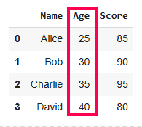
Sort Pandas DataFrame
In this example, the DataFrame is sorted by the Age column in ascending order. Now let’s dive deeper into how this works.
Sorting is essential when dealing with large datasets as it helps organize and interpret data more efficiently. In Pandas, the sort_values() method allows you to sort a DataFrame by one or more columns. By default, it sorts in ascending order but can be customized with various parameters.
Key Parameters of sort_values():
- by: Specifies the column(s) to sort by.
- ascending: Boolean (default True). If False, sorts in descending order.
- inplace: If True, modifies the original DataFrame; otherwise returns a new sorted DataFrame.
- na_position: Specifies whether to place NaN values at the beginning (‘first’) or end (‘last’).
- ignore_index: If True, resets the index after sorting.
By default, the sorting is done in ascending order. If you want to sort in descending order, you can set the ascending parameter to False.
import pandas as pd
data = {'Name': ['Alice', 'Bob', 'Charlie', 'David'],'Age': [25, 30, 35, 40],'Score': [85, 90, 95, 80]}
df = pd.DataFrame(data)
# Sorting by 'Age' in descending order
sorted_df = df.sort_values(by='Age',ascending=False)
print(sorted_df)
Output
Name Age Score
3 David 40 80
2 Charlie 35 95
1 Bob 30 90
0 Alice 25 85
2. Sort DataFrame by Multiple Columns
Sometimes, you need to sort your data based on multiple criteria. For example, you might want to sort by age and then by name. You can achieve this by passing a list of column names to the by parameter.
import pandas as pd
data = {'Name': ['Alice', 'Bob', 'Charlie', 'David'],
'Age': [25, 30, 35, 40],
'Score': [85, 90, 95, 80]}
df = pd.DataFrame(data)
# Sorting by 'Score' in ascending order
sorted_df = df.sort_values(by=['Age', 'Score'])
print(sorted_df)
Output
Name Age Score
0 Alice 25 85
1 Bob 30 90
2 Charlie 35 95
3 David 40 80
This will first sort by Age, and if there are ties (same age), it will then sort by Score. You can also specify different sort orders for each column by using the ascending parameter with a list of boolean values.
3. Sort DataFrame with Missing Values
When datasets contain missing values, sorting behavior can be controlled using na_position parameter in sort_values(). By default, missing values are placed last, but you can place them first if needed.
import pandas as pd
data_with_nan = {"Name": ["Alice", "Bob", "Charlie", "David"],"Age": [28, 22, None, 22]}
df_nan = pd.DataFrame(data_with_nan)
# Sort by 'Age', placing missing values first
sorted_df = df_nan.sort_values(by="Age", na_position="first")
print(sorted_df)
Output
Name Age
2 Charlie NaN
1 Bob 22.0
3 David 22.0
0 Alice 28.0
The na_position='first' option moves rows with NaN values to the top during sorting.
Choosing the Sorting Algorithm
Pandas allows you to specify the sorting algorithm using the kind parameter. The available options are:
- 'quicksort': Quicksort is a highly efficient, divide-and-conquer sorting algorithm. It selects a “pivot” element and partitions the dataset into two halves: one with elements smaller than the pivot and the other with elements greater than the pivot.
- 'mergesort': Divides the dataset into smaller subarrays, sorts them, and then merges them back together in sorted order.
- 'heapsort': Heapsort is another comparison-based sorting algorithm that builds a heap data structure to systematically extract the largest or smallest element and reorder the dataset.
To better demonstrate the behavior and benefits of using the 'mergesort' algorithm, particularly its stability, let’s modify the example to include duplicate values in the column being sorted.
import pandas as pd
# Create a DataFrame with duplicate 'Age' values
data = {
"Name": ["Alice", "Bob", "Charlie", "David", "Eve"],
"Age": [28, 22, 25, 22, 28],
"Score": [85, 90, 95, 80, 88]
}
9
df = pd.DataFrame(data)
# Sort the DataFrame by 'Age' using the 'mergesort' algorithm
sorted_df = df.sort_values(by='Age', kind='mergesort')
print(sorted_df)
Output:
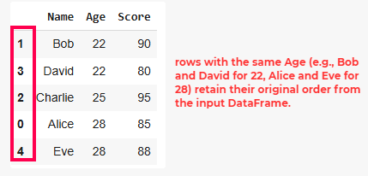
Sort Pandas DataFrame
Stability ensures that the relative order of rows with equal values in the sorting column is preserved.
Custom Sorting with Key Functions
You can also apply custom sorting logic using the key parameter. For example, let’s say you want to sort strings ignoring case sensitivity:
import pandas as pd
data = {
"Name": ["Alice", "Bob", "Charlie", "David", "Eve"],
"Age": [28, 22, 25, 22, 28],
"Score": [85, 90, 95, 80, 88]
}
df = pd.DataFrame(data)
sorted_df = df.sort_values(by='Name', key=lambda col: col.str.lower())
print(sorted_df)
Output
Name Age Score
0 Alice 28 85
1 Bob 22 90
2 Charlie 25 95
3 David 22 80
4 Eve 28 88
This ensures that names are sorted alphabetically without considering case differences.
Key Takeaways:
- sort_values() is versatile and allows sorting by one or multiple columns.
- You can control whether sorting is ascending or descending using the ascending parameter.
- Missing values (NaN) can be placed at either the beginning or end using the na_position parameter.
- Custom sorting logic can be applied using the key parameter.

- Pivot Table in Pandas

A pivot table is a statistical table that summarizes a substantial table like a big dataset. It is part of data processing. This summary in pivot tables may include mean, median, sum, or other statistical terms. Pivot tables are originally associated with MS Excel but we can create a pivot table in Pandas using Python using the Pandas Dataframe pivot_table() method.
Creating a Sample DataFrame
Let’s first create a dataframe that includes Sales of Fruits.
- Python3

# importing pandas
import pandas as pd

# creating dataframe
df = pd.DataFrame({'Product': ['Carrots', 'Broccoli', 'Banana', 'Banana',
'Beans', 'Orange', 'Broccoli', 'Banana'],
'Category': ['Vegetable', 'Vegetable', 'Fruit', 'Fruit',
'Vegetable', 'Fruit', 'Vegetable', 'Fruit'],
'Quantity': [8, 5, 3, 4, 5, 9, 11, 8],
'Amount': [270, 239, 617, 384, 626, 610, 62, 90]})
df
Output
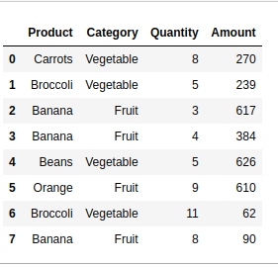
Create a Pivot Table in Pandas
Below are some examples to understand how we can create a pivot table in Pandas in Python:
Example 1: Get the Total Sales of Each Product
In this example, the DataFrame ‘df’ is transformed using a pivot table, aggregating the total ‘Amount’ for each unique ‘Product’ and displaying the result with the sum of amounts for each product.
- Python3

pivot = df.pivot_table(index=['Product'],
values=['Amount'],
aggfunc='sum')
print(pivot)
Output
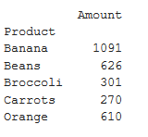
Example 2: Get the Total Sales of Each Category
In this example, a pivot table is created from the DataFrame ‘df’ to summarize the total ‘Amount’ sales for each unique ‘Category,’ employing the ‘sum’ aggregation function, and the result is printed.
- Python3

# creating pivot table of total
# sales category-wise aggfunc = 'sum'
pivot = df.pivot_table(index=['Category'],
values=['Amount'],
aggfunc='sum')
print(pivot)
Output
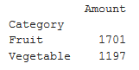
Example 3: Get Total Sales by Category and Product Both
In this example, a pivot table is generated from the DataFrame ‘df’ to showcase the total ‘Amount’ sales for unique combinations of ‘Product’ and ‘Category,’ utilizing the ‘sum’ aggregation function. The resulting pivot table is then printed.
- Python3

pivot = df.pivot_table(index=['Product', 'Category'],
values=['Amount'], aggfunc='sum')
print(pivot)
Output
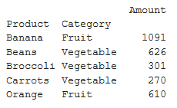
Example 4: Get the Mean, Median, Minimum Sale by Category
In this example, a pivot table is created from the DataFrame ‘df’ to display the median, mean, and minimum ‘Amount’ values categorized by ‘Category.’ The aggregation functions ‘median,’ ‘mean,’ and ‘min’ are applied, and the resulting pivot table is printed.
- Python3

# 'mean', 'min'} will get median, mean and
# minimum of sales respectively
pivot = df.pivot_table(index=['Category'], values=['Amount'],
aggfunc={'median', 'mean', 'min'})
print(pivot)
Output
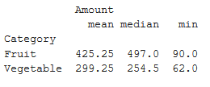
Example 5: Get the Mean, Median, Minimum Sale by Product
In this example, a pivot table is generated from the DataFrame ‘df’ to showcase the median, mean, and minimum ‘Amount’ values for each unique ‘Product.’ The aggregation functions ‘median,’ ‘mean,’ and ‘min’ are applied, resulting in the pivot table, which is then printed.
- Python3

pivot = df.pivot_table(index=['Product'], values=['Amount'],
aggfunc={'median', 'mean', 'min'})
print(pivot)
Output
